## **CHAUDHARY HAMDAN**

**1905387**

**OOP LAB-5**

**Date : 04-09-2020**

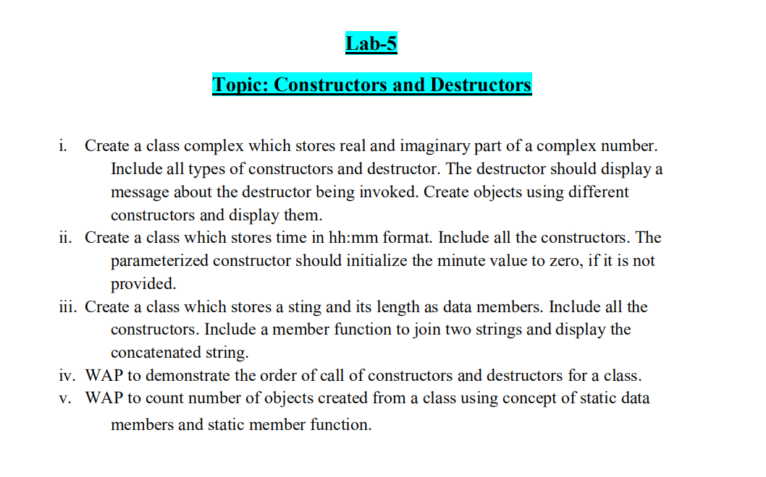

1.

#include<iostream>

using namespace std;

class complex

{

int real,img;

public:

complex()

{

real=10;

img=6;

}

complex(int a, int b)

{

real=a;

img=b;

}

complex(const complex &x,const complex &y)

{

real=x.real;

img=y.img;

}

void display()

{

cout<<"The number is:\n";

cout<<real<<"+"<<img<<"i"<<endl;

}

~complex()

{

cout<<"Destructor called"<<endl;

}

};

int main()

{

complex c1;

c1.display();

complex c2(12,8);

c2.display();

complex c3(c1);

c3.display();

complex c4(c2);

c4.display();

return 0;

}

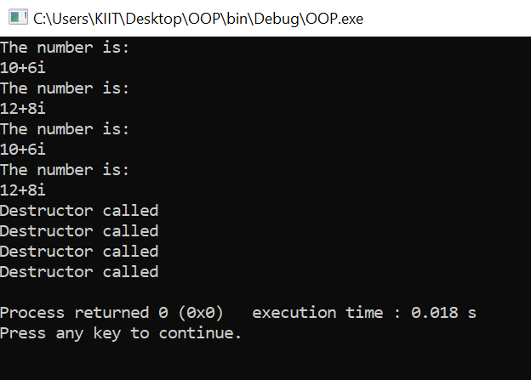

2.

#include<iostream>

using namespace std;

class time1{

int hour,minu,sec;

public:

time1()

{

hour=14;

minu=3;

sec=2000;

}

time1(int h,int s,int m=0){

hour=h;

minu=m;

sec=s;

}

time1(const time1 &x,const time1 &y,const time1 &z){

hour=x.hour;

minu=y.minu;

sec=z.sec;

}

void display(){

minu=minu+(sec/60);

sec=sec%60;

hour=hour+(minu/60);

minu=minu%60;

cout<<hour<<":"<<minu<<":"<<sec<<endl;

}

};

int main()

{

time1 t1;

t1.display();

time1 t2(4,94);

t2.display();

time1 t3(t1);

t3.display();

time1 t4(t2);

t4.display();

return 0;

}

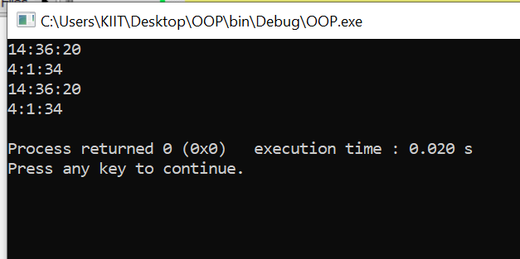

3.

#include<iostream>

#include<string.h>

using namespace std;

class mystring

{

int len;

char *name;

public:

mystring()

{

len=0;

name=new char;

}

mystring(char *s)

{

name=new char[strlen(s)+1];

len=strlen(s);

strcpy(name, s);

}

~mystring()

{

delete name;

}

void join(mystring &s1, mystring &s2)

{

len=s1.len+s2.len;

name=new char[len+1];

strcpy(name, s1.name);

strcat(name, s2.name);

}

void display()

{

cout<<"The string is: "<<name<<endl;

}

void display1()

{

cout<<"The concatenated string is: "<<name<<endl;

}

};

int main()

{

mystring c1("Loveable "), c2("KIITian"), c3;

c3.join(c1,c2);

c1.display();

c2.display();

c3.display1();

return 0;

}

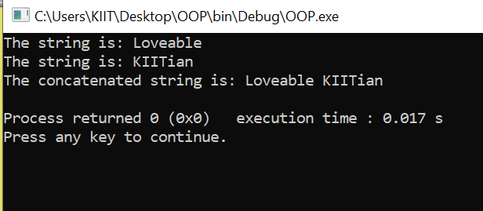

4.

#include <iostream>

using namespace std;

class A

{

public:

A()

{

cout << "Constructor called now\n";

}

void fun()

{

cout << "Function Callewd now\n";

}

~A()

{

cout << "Destructor called now\n ";

}

};

int main()

{

A ob;

ob.fun();

return 0;

}

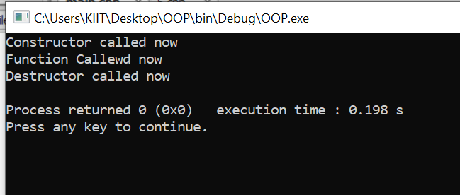

5.

#include <iostream>

using namespace std;

class A

{

static int c;

public :

A()

{

c++;

cout << "Object Created " << endl;

}

static void display()

{

cout << c << endl;;

}

};

int A :: c;

int main()

{

A ob1;

A ob2;

A ob3;

A ob4;

cout << "\nObjects Created are " ;

A :: display();

A ob5;

cout << "\nObjects Created are " ;

A :: display();

return 0;

}

